**Relax Take-Home Challenge**

After analyzing the data, it seems that the factor that is most likely to predict user adoption is the time of the user’s last login. I attempted feature engineering to see if there is a correlation between how many times a user successfully invited other users and whether they can be consider adopted users. Although this did not show a high correlation to user adoption, it was the third highest behind the id of the organization the user worked in. Shown below is a heat map of the correlation matrix as well as the values from this matrix in relation whether someone is considered an adopted user.

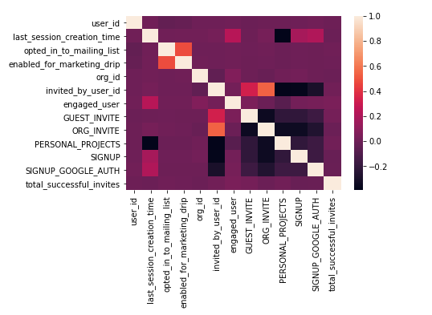

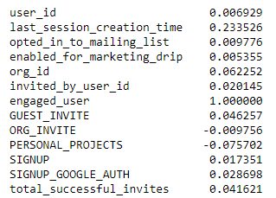

I also attempted some models to see if we can successfully predict user adoption based on the factors we have. The best model seemed to be Gradient Boosting which showed the classification report below.

